BA 64060 Final Project Report
Clustering Analysis of US Power Generation (EIA-923, 2020) & COVID-19 Impact
GROUP – 08



Instructor’s Name: -Mostafa Kamali Ardakani

S.NO | NAME | STUDENT ID | CONTRIBUTION
1. | Akshar DilipKumar Patel | 811359891 | Data cleaning, feature engineering, K-means model, report & PPT sections
2. | Sai Ashrith Kumar Gajwelli | 811317143 | K-Means model, Elbow/Silhouette analysis, report & PPT visuals
3. | Cole Yagersz | 811149856 | Data aggregation, monthly trend/COVID analysis, report & PPT findings

1. Executive Summary
The 2020 EIA-923 US power plant generation dataset is exposed to machine learning clustering techniques with the goal to find notable production-based power plant segments. These segments are investigated to see how the COVID-19 pandemic has changed the power plants' production characteristics. We implement K-means clustering applying annual generation and thermal efficiency after compiling and filtering the data. Using silhouette scores and the elbow strategy seven clusters were identified to be the most beneficial. All clusters' monthly generation records during the COVID-19 pandemic demonstrate a drop in the demand for electric power across the entire spectrum. This distinction makes it simpler to comprehend how US power plants are different technically and how they address the pandemic.
2. Introduction
The US Energy Information Administration's EIA-923 form produced the project's data. This form aggregates monthly data from all US power amenities relating to fuel utilization and electrical generation. To analyze what sorts of changes transpired during this time, we used the 2020 dataset, since that was the year when the pandemic has an impact on plant operations.
Data Cleaning & Preparation
- Extracted data from Page 1 - Generation and Fuel Data
- Retained essential variables:
  - Plant identification, Fuel Type, and Monthly Net Generation
- Handled issues
  - Removed variables with significant missing values
  - Filled missing monthly values with zeros
  - Standardized column names and corrected datatypes
- Aggregated multiple plant-unit records into a plant-level dataset
- Filtered plants (negative or zero generation, unrealistic efficiency)
- Calculated Thermal Efficiency
- Final Dataset 3290 plants ready for clustering

3. Problem Statement
The aim for this study is to use real-world data and machine learning techniques to recognize patterns in the US power generation. Despite the 2020 EIA-923 dataset providing extensive monthly and annual data on thousands of power plants, decision-makers finding it harder to extract significant information using it owing to its magnitude and complexity Also The study will use clustering analysis to separate power plants into groups with equivalent operational attributes with the purpose of circumventing this issue.

This study aims to answer the following key questions:
- What meaningful groups of U.S. power plants emerge when plants are clustered based on annual electricity generation and thermal efficiency?
Differences in scale, performance, and fuel type that are not clear in raw data can be revealed by recognizing each of these groups.
- How should the optimal number of clusters be determined?
To determine a model that more accurately captures the underlying data and the project compares multiple cluster counts using the elbow process and silhouette scores.
- What information does the clustering process reveal about power generation patterns across the United States?
This study discovers specific characteristics involving generation scale, efficiency and basic fuel sources through analysis of each cluster.
- How did different types of power plants behave during the early months of the COVID-19 pandemic (March to May 2020)?
Monthly generation reports provided insight into how various energy sector segments have been impacted by demand shocks.

The main objective is to present utilities, regulators and policymakers a clear, data-driven segmentation of U.S. power plants that can assist them comprehend system behavior, resource planning specifications, and probable areas for operational improvement.

4. Analysis and Discussion
4.1 Data Preparation and Feature Selection
The original dataset included more than 97 variables containing plant identifiers, fuel information, monthly generation and annual totals. To make the data suitable for machine learning, column names were standardized, and only essential variables were retained, such as plant ID, location, reported fuel type, monthly generation values, total annual generation and total fuel energy input.
To attempt to fix missing or inconsistent values, fields were altered to numeric formats, and when generation was not reported, zeros were allocated. Zeros have been approved as valid applications because many plants operate occasionally. A clean, plant-level data set was created by combining all records that corresponded to the same plant.
The most important one of the new performance measures generated by feature design is thermal efficiency, and this is established by reducing total annual output by total fuel energy. Furthermore, a log transformation of annual generation was utilized to improve clustering performance and minimize skewness.
4.2 Clustering Methodology
The project used K-Means clustering, an unsupervised method that groups observations with similar characteristics. Clustering was performed using two standardized features:
- Log-transformed annual generation
- Thermal efficiency
Standardization prevented massive generation values from dominating the results and maintained that both features contributed equally. The entire data set was used for model training to try to capture all the structural variability observed among U.S. power plants, as clustering is exploratory rather than predictive.
4.3 Choosing the Optimal Number of Clusters
Two evaluation approaches, the Elbow Method and the Silhouette Score had been implemented to figure out the right number of clusters. For K values between 2 and 10, both metrics were generated.
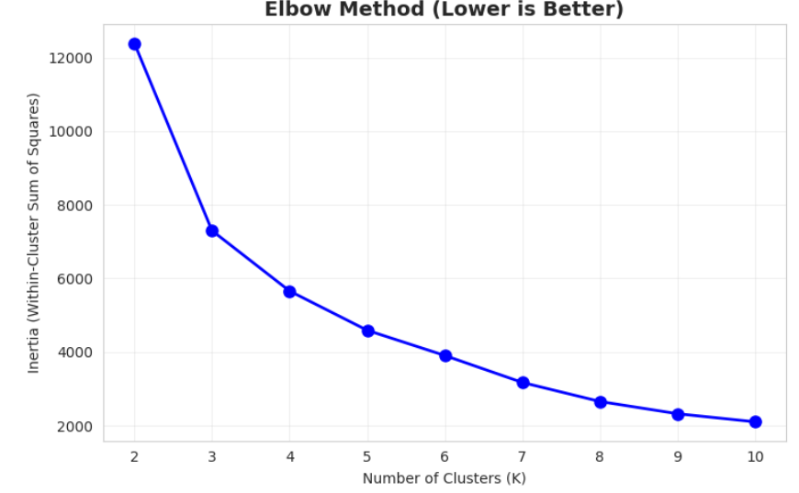
The Elbow Method plot is displayed in Figure 1 . The graph illustrates how inertia first decreases drastically until flattening toward at K = 7, demonstrating that the improvement declines as extra clusters are applied.
Figure 1. Elbow plot indicating optimal K

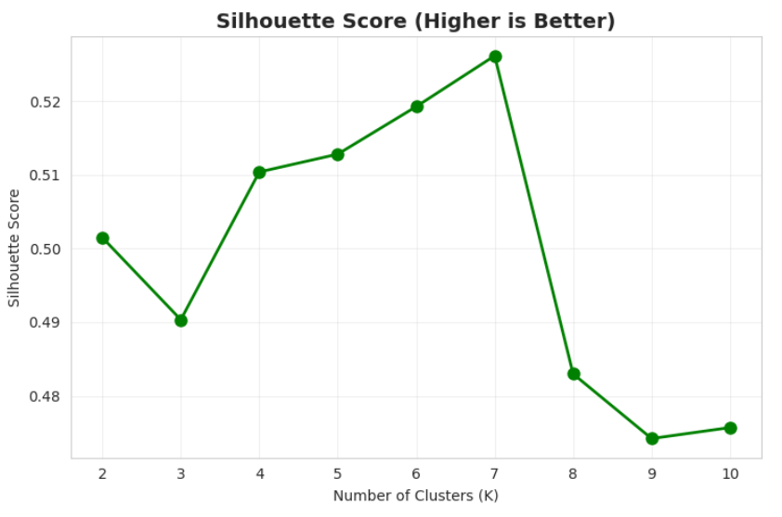
Similarly, Figure 2 displays the Silhouette Score for the same range of K values. The Silhouette Score measures how well-separated the clusters and the highest value occurred at K = 7, confirming that this number provides the best cluster separation.
Figure 2. Silhouette plot showing optimal K

Since both methods aligned, seven clusters were selected. This number provided clear distinctions between plant types without creating unnecessary complexity.
4.4 Interpretation of Cluster Profiles
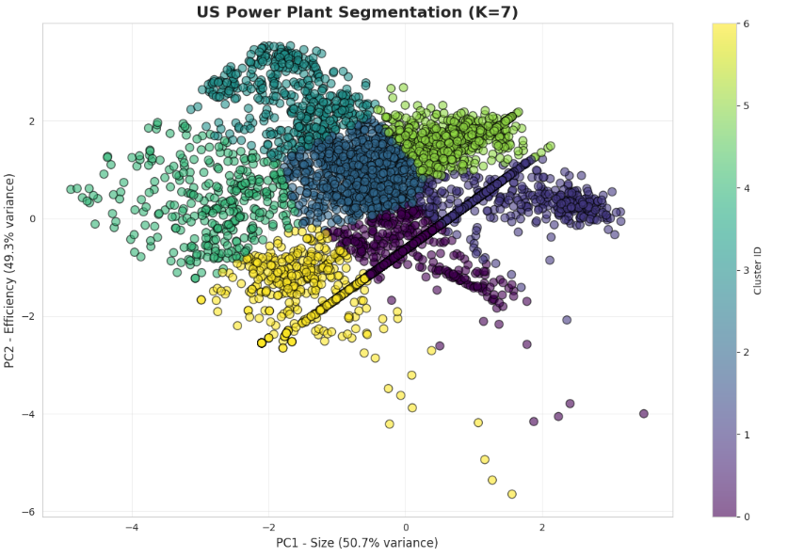
The seven clusters symbolize in various operational tasks in the American electrical network.The organization of plants based upon size and efficiency was shown utilizing a PCA visualization.
Figure 3. PCA visualization of the seven power plant clusters (K = 7).

Below is a description of each cluster:
Cluster 5 – “The Backbone” (Large Gas Plants)
Most of the nation's electricity has been generated through that reasonably substantial group. These powerful natural gas installations operate as major base-load vendors.
Cluster 1 – “Wind Heavy” (Large Renewable Group)
A very large group dominated by wind facilities. High efficiency and major contributions to renewable energy goals define this cluster.
Cluster 0 – “Solar Army” (Distributed Solar Segment)
The largest cluster by count. Composed mainly of small but efficient solar installations with strong seasonal patterns.
Cluster 2 – “Local Gas” (Mid-Sized Gas Plants)
moderate efficiency and efficacy in the center. These manufacturing operations generally serve regional or local requirements.
Cluster 3 – “Emergency Backup” (Oil-Fired Plants)
Low-efficiency plants used primarily during peak periods or emergencies, operating infrequently and at higher cost.
Cluster 4 – “Inefficient Peakers” (Small Gas Units)
older, ineffectual gas units that only activate whenever demand is high.
Cluster 6 – “High-Efficiency Backup” (Mixed Fuels)
Employing a variety of fuels, these power plants is small and quite efficient. Their low but continuous generation levels coincide with position in additional amenities and durability.
Overall, these clusters highlight clear operational divisions: base-load suppliers, renewables, distributed generators and various forms of backup capacity.

4.5 Monthly Patterns and COVID-19 Impact (March–May 2020)
Monthly generation trends were analyzed to understand how each cluster performed throughout 2020, with particular attention March to May, the months most affected by early COVID-19 lockdowns. Figure 4 below illustrates these monthly patterns across all seven clusters.
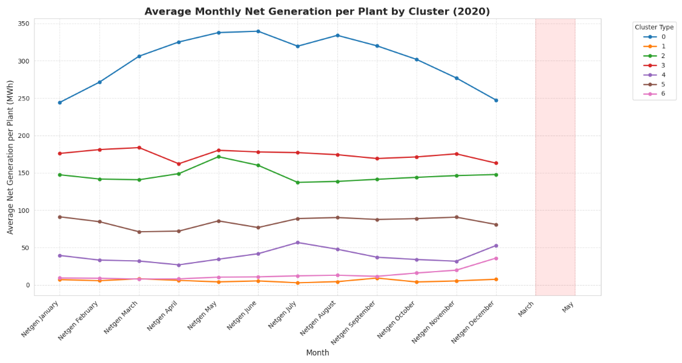
The plot highlights several important patterns:
Figure 4.Average monthly net generation per plant by cluster (2020)
- From the months of March to May 2020, there will be a drop in large gas plants (Cluster 5).
- Wind and solar clusters reflect seasonal behavior rather than pandemic-driven changes.
- Backup/Peaker clusters show consistently low output with further dips during the early pandemic months.
- Local gas plants follow national demand trends with modest reductions.
In summary, significant fossil fuel operations and Peaker units demonstrated the strongest COVID-19 effects, but renewable clusters maintained to demonstrate regular seasonal instability.

5. Conclusion
This project analyzed 2020 EIA-923 power plant data employing machine learning to find major patterns in the manufacturing of power in the United States of America. Seven distinct facility categories, ranging from significant natural gas base-load units to major wind and solar clusters and multiple backup or Peaker plants, were discovered by K-Means clustering followed the design and engineering of features including annual generation and thermal efficiency. From March to May 2020, the monthly mean demonstrated distinctive seasonal behavior among renewables and substantial COVID-19-related declines in output for important gas and Peaker units. All things examined, the clustering approach effectively separated extensive energy data into accessible operational categories that might help in planning and policy selections. To further develop system-level insights, further studies might look at additional indicators including emissions, capacity, cost or multi-year trends.

Data Sources: -https://www.google.com/url?q=https%3A%2F%2Fwww.eia.gov%2Felectricity%2Fdata%2Feia923%2Farchive%2Fxls%2Ff923_2020.zip

